HIGHLIGHT CHART

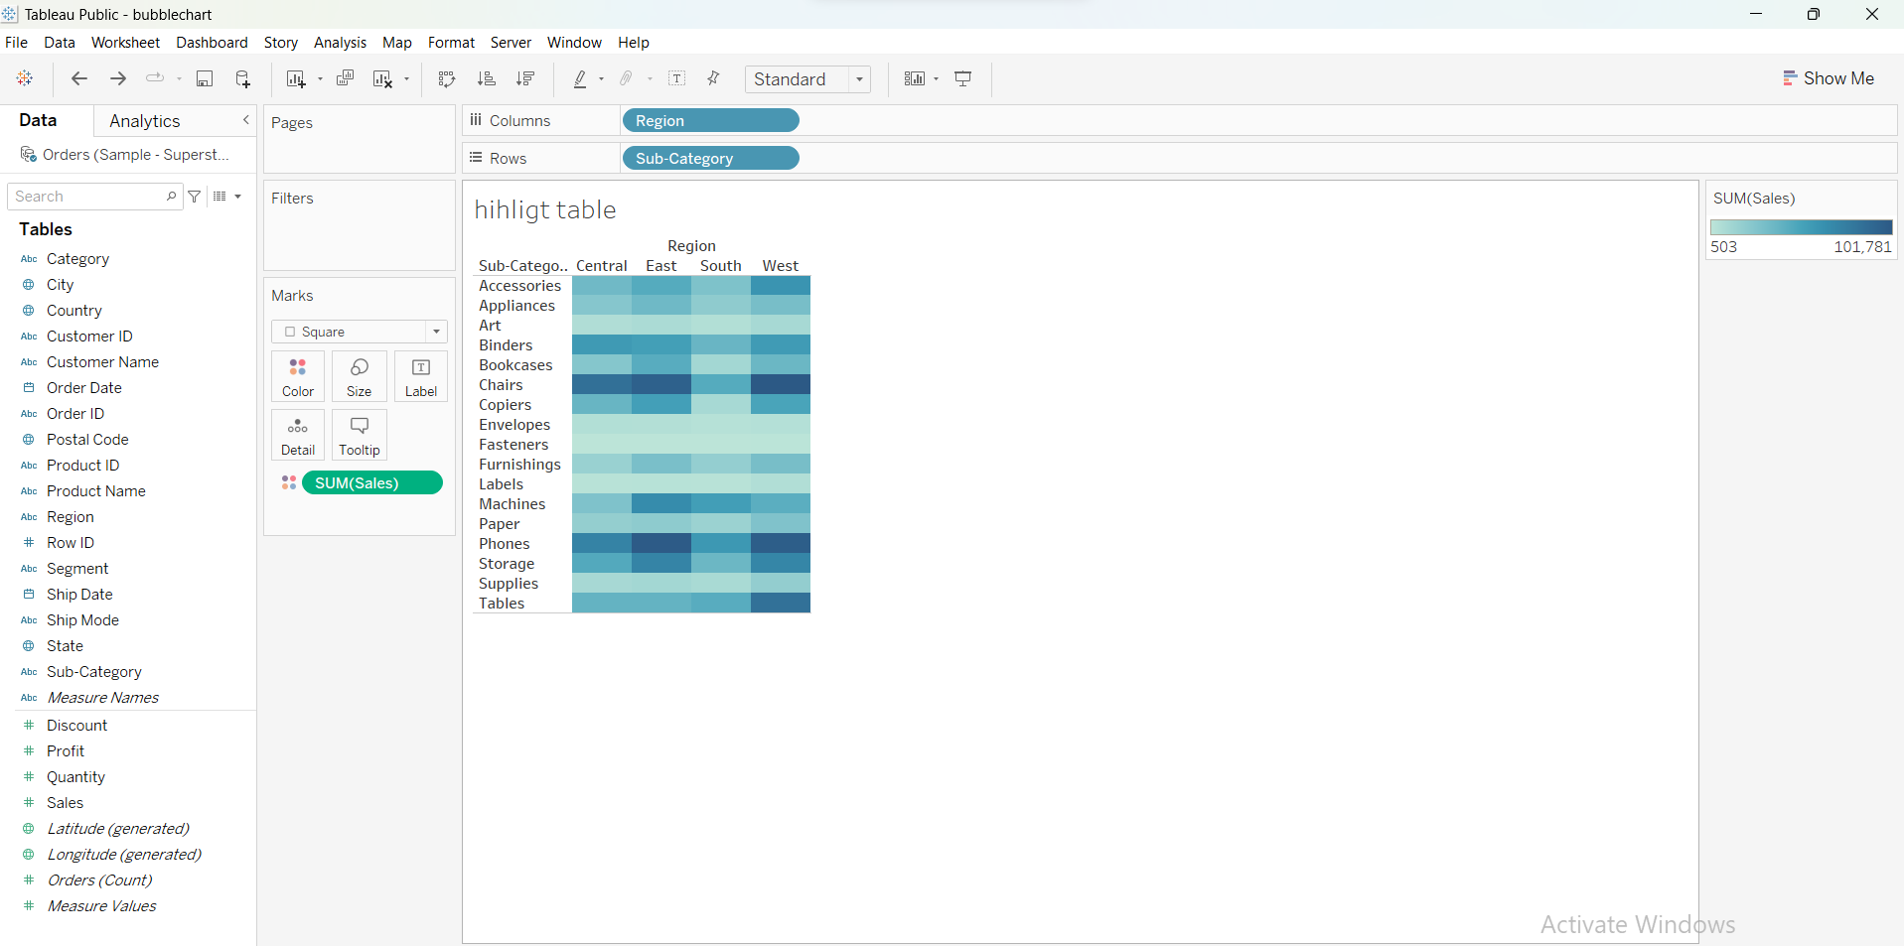

Bar chart

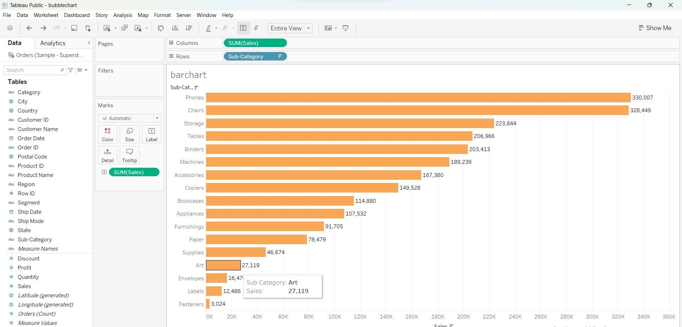

Column chart

Stacked bar chart

Line chart

Scatter plot

Treemap

Bubble chart

Wordcloud

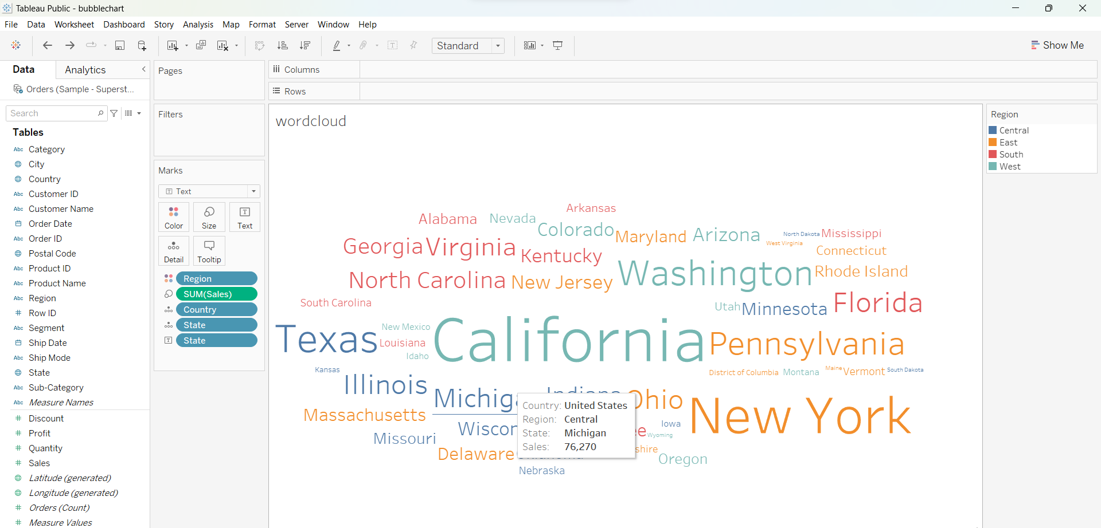

Comnined axis chart : move measure values to y axis

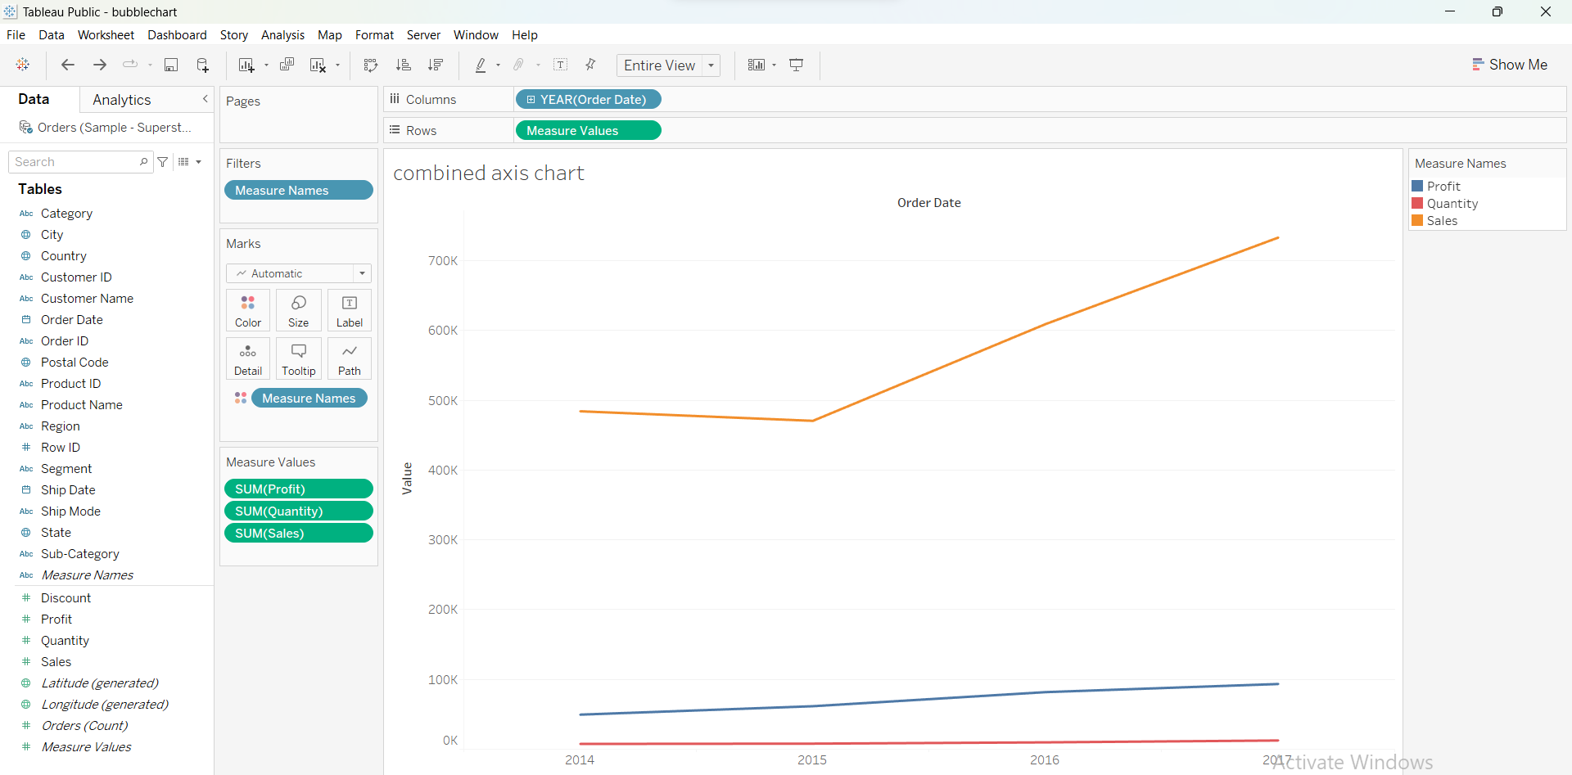

Line vs bar

Bar in bar

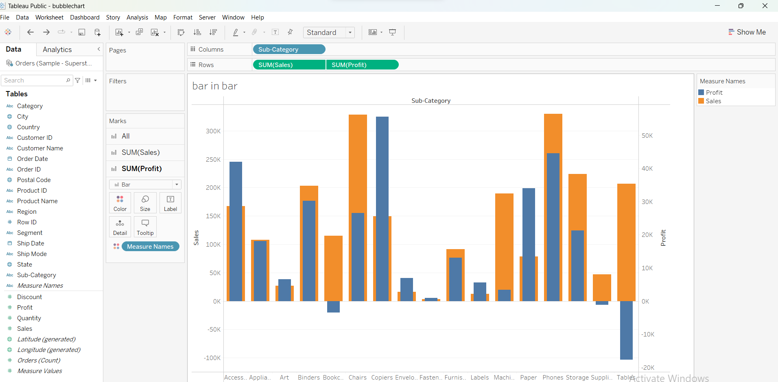

Funnel chart

Map

Waterfall chart

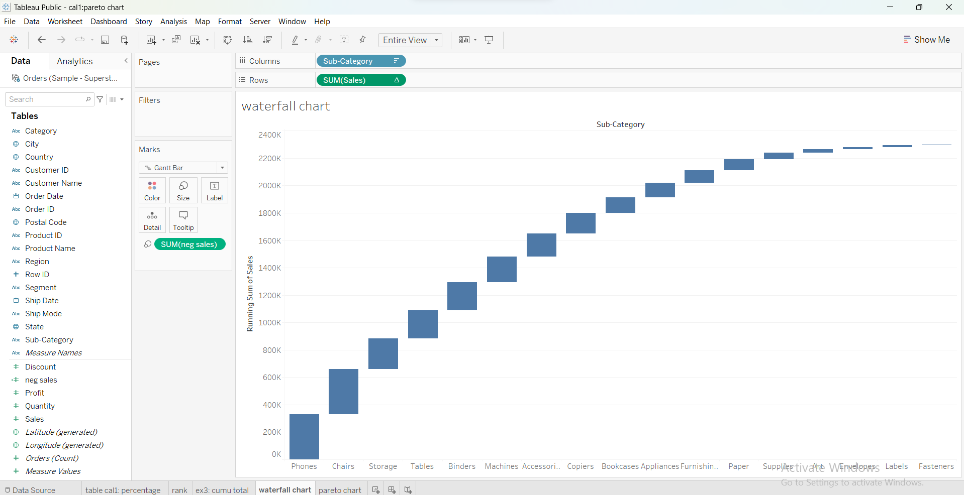

Parerto chart

Trend line

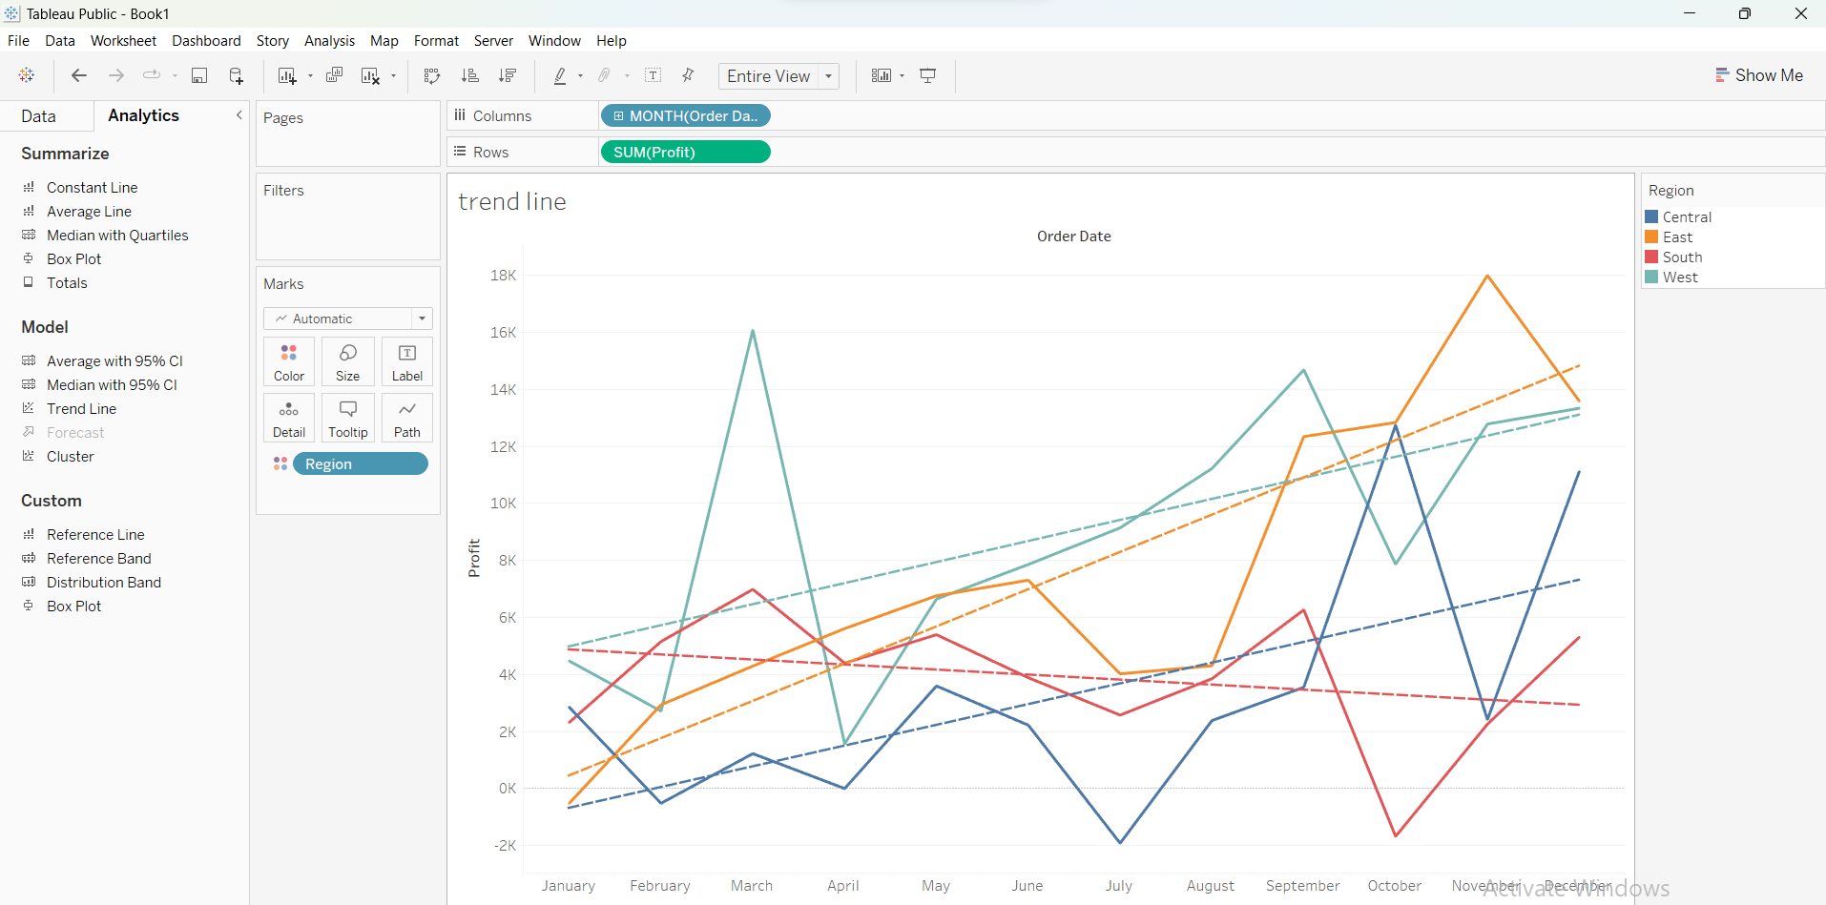

Refrence bands

Distribution bands

Bullet chart

Boxplot

Forecasting

Clustering

